Business Analytics 1

Sai Kiran

2023-02-18

#installing and calling the ISLR Package

library(ISLR)  
library("knitr")  
library("tinytex")

#printing the summary and the total number of rows of the carseats dataset

summary(Carseats)

## Sales CompPrice Income Advertising   
## Min. : 0.000 Min. : 77 Min. : 21.00 Min. : 0.000   
## 1st Qu.: 5.390 1st Qu.:115 1st Qu.: 42.75 1st Qu.: 0.000   
## Median : 7.490 Median :125 Median : 69.00 Median : 5.000   
## Mean : 7.496 Mean :125 Mean : 68.66 Mean : 6.635   
## 3rd Qu.: 9.320 3rd Qu.:135 3rd Qu.: 91.00 3rd Qu.:12.000   
## Max. :16.270 Max. :175 Max. :120.00 Max. :29.000   
## Population Price ShelveLoc Age Education   
## Min. : 10.0 Min. : 24.0 Bad : 96 Min. :25.00 Min. :10.0   
## 1st Qu.:139.0 1st Qu.:100.0 Good : 85 1st Qu.:39.75 1st Qu.:12.0   
## Median :272.0 Median :117.0 Medium:219 Median :54.50 Median :14.0   
## Mean :264.8 Mean :115.8 Mean :53.32 Mean :13.9   
## 3rd Qu.:398.5 3rd Qu.:131.0 3rd Qu.:66.00 3rd Qu.:16.0   
## Max. :509.0 Max. :191.0 Max. :80.00 Max. :18.0   
## Urban US   
## No :118 No :142   
## Yes:282 Yes:258   
##   
##   
##   
##

nrow(Carseats)

## [1] 400

#printing the maximum value of the advertising attribute

max(Carseats$Advertising)

## [1] 29

#printing the IQR of the Price attribute.

IQR(Carseats$Price)

## [1] 31

#plotting sales against price and printing the correlation between two

correlation <- cor(Carseats$Sales, Carseats$Price)  
plot(Carseats$Price, Carseats$Sales, xlab = "Price", ylab = "Sales")  
abline(lm(Sales ~ Price, data = Carseats), col = "grey")

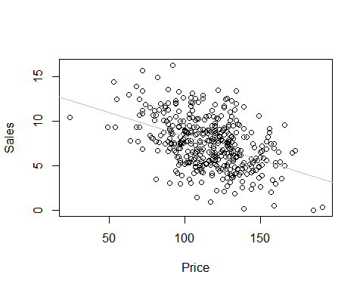

print(paste("The correlation between Sales and Price is:", correlation))

## [1] "The correlation between Sales and Price is: -0.444950727846573"

**From the plot we can say that the attributes price and the sales are negatively correlated**